Important decision: board developed will be a PCB (industry safe, foolproofing, modifiable circuits aren’t understandable to most end users, etc)

# Brain Interfacing – Jetson Nano 2GB Developer Kit

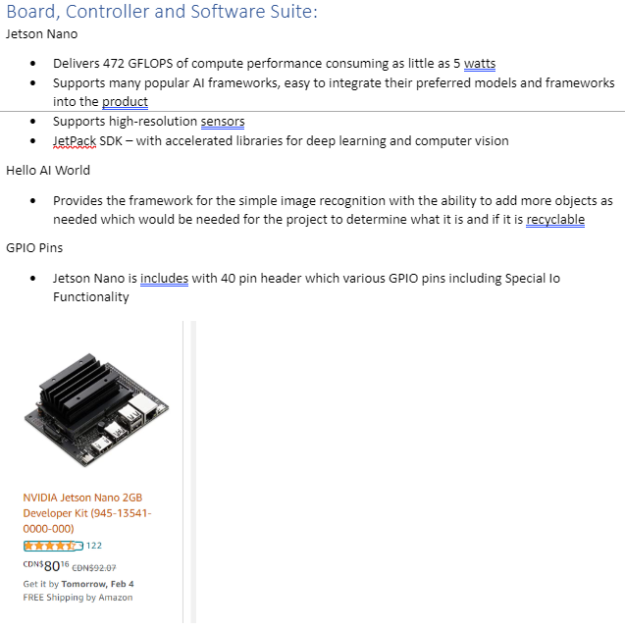

[1]

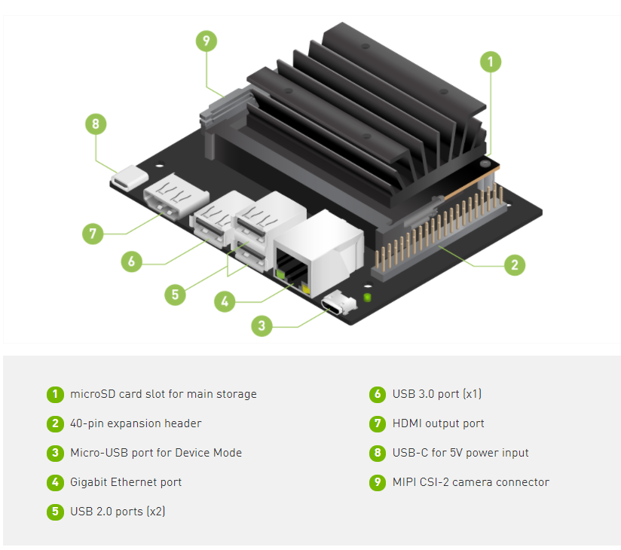[2]

## Power

5W – 5V [2] Therefore max 1A? NOPE! SEE NEXT COUPLE OF LINES

USB-C takes 5V

Website says USB-C 5V 3A

Can be powered via two 5V pins at 2.5A each – pins 2&4 [3] NOT AT SAME TIME AS USB-C

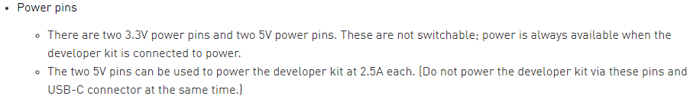

## Control

40xpins, some of which are GPIO, I2C, I2S, SPI, PWM, UART

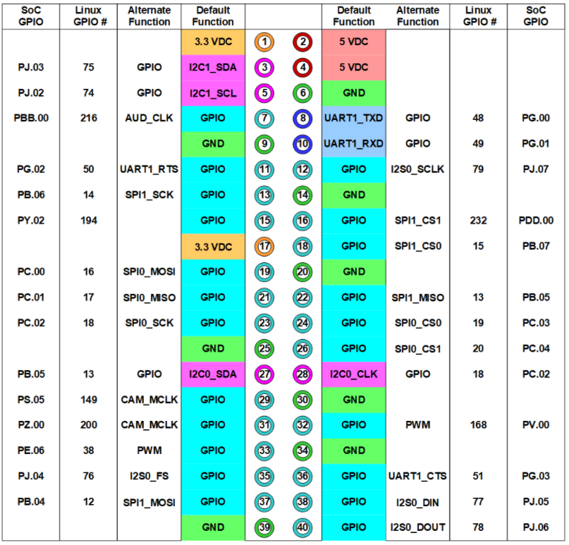

[3]



2xUSB 2.0

1xUSB 3.0

For now, ask controls if there is a preferred pin to control motors once I’ve figured out how many pins req’d to control motors

## Connections

2x40 female headers on electrical board input

2x40 male headers on electrical board output

## References

[1] Controls – Parts and Software Research

[2] https://developer.nvidia.com/embedded/learn/get-started-jetson-nano-2gb-devkit

[3] https://developer.nvidia.com/embedded/learn/jetson-nano-2gb-devkit-user-guide#id-.JetsonNano2GBDeveloperKitUserGuidevbatuu_v1.0-40-PinHeader(J6)

# Hardware Interfacing – Actuation

General design:

* Put things in
* Funnel centres things
* Need actuator to release funnel – ACTUATOR
* Chutes & diverter – ACTUATOR

Emily’s goal: 2 motors total

* PM suggested designing for expansion I.e. make 3 motors possible (DC DC converter needs to handle Jetson 2x 2.5A, motors 3x 0.35A

Stepper motor is strong at holding – likely enough for both

Current motor proposed: <https://www.digikey.ca/en/products/detail/adafruit-industries-llc/324/5022791?fbclid=IwAR1hBmm7v0-VDSBxY0rTDldf8Dfax2efxdF4llndxuVyXe9BNx3K50K0BJM>

Much info about steppers available at <https://cdn-learn.adafruit.com/downloads/pdf/all-about-stepper-motors.pdf>

This is a Hybrid stepper – look for available drivers

All coils in phase energised together

## Power

V=12V, I=0.35A, R=34Ohm, L=33mH parameters given in datasheets

Low efficiency

## Control

How is stepper motor controlled? Several wires given. Pulse to rotate? How to counter-rotate?

Position feedback – limit switches/home detectors req’d for safety or to establish reference

* Promising limit switch: <https://www.digikey.ca/en/products/detail/panasonic-electronic-components/ESE-11MH5T/354737>
  + Sent to mech to verify that it is suitable

Adafruit Motor Shield drives up to 2 stepper motors, mounts onto Arduino but we ain’t using Arduino: <https://cdn-learn.adafruit.com/downloads/pdf/adafruit-motor-shield-v2-for-arduino.pdf>

2x [this](https://www.digikey.ca/en/products/detail/adafruit-industries-llc/2448/5353672?utm_adgroup=Evaluation%20and%20Demonstration%20Boards%20and%20Kits&utm_source=google&utm_medium=cpc&utm_campaign=Shopping_Product_Development%20Boards%2C%20Kits%2C%20Programmers&utm_term=&productid=5353672&gclid=CjwKCAiAg8OBBhA8EiwAlKw3krw6HAmHv_jSdFkx8obsIDKbzn6H-4zbtJqad1KGd3_9qJvvv53AmhoCINoQAvD_BwE) will do the trick for controlling one servo, $6.85 each

## Connections

non-mating crimp – secure connection; cheap; modifiable for testing purposes: link

Dismissed options: ring termnal (expensive, requires extra PCB modification to allow screw connection); (screw terminals – less secure as tension can pull wire out of grip)

# Power – Sum of Other Needs

Do we want to implement a button to turn the system on?

* Jetson 12-Pin Button Header can disable auto-system-on
* Power drain? Do we want to just put a switch in the power assembly?

Need 12V & 5V for motors/drivers and 5V for Jetson Nano

Jetson Nano needs up to 2.5A per pin

Motors need up to 0.35A each - how does Nano interface with motors? Adafruit driver found

Buck converter: <https://www.digikey.ca/en/products/detail/intel/EC2650QI/10187118>

* This converter has poor documentation

Buck converter: <https://www.digikey.ca/en/products/detail/flex-power-modules/PMU8418-D/11581928>

* Better documentation

Buck converter: <https://www.digikey.ca/en/products/detail/bel-fuse-inc/VRAE-10E1A0G/1754625>

* Testable (through hole, easily accessible terminals)
* Overkill for the application – future expansion e.g. adding motors

## Connections

Wall AC to 12Vdc wall wart, barrel jack in to board. Works for Arduino, works for this. Check current capacity before final choice.

# Future

Be sure of power